Study recap
Ecologically, the ocean sediment microbial communities are largely unmapped. Microbial communities play an important role in ecosystem health through nutrient cycling and organic matter degradation. This particular study will gather baseline microbial species data from sites within a national marine sanctuary for the areas open vs. closed to commercial and recreational fishing. The outcome of a detailed taxonomic structure will be expressed as the relative abundance and biodiversity of bacteria present.

The worldwide increase in antibiotic resistant pathogens has led to efforts to explore the seafloor habitat through species characterization and natural product bioprospecting. There is potential for discovering novel bacterial strains and biosynthetic compounds since extreme conditions in which these organisms have evolved has led to genetic adaptations for survival. This project will use next generation metagenomic sequencing used in combination with bioinformatics to carry out this survey. We are also excited to combine this year’s data and statistical analyses with the ongoing research (summer, fall 2016-17).

Final preparations underway for summer expedition
Logistics: The research vessel upgrades completed. Our crew, sampling supplies and equipment are coming together.

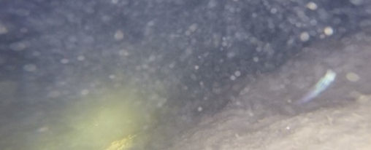Seafloor sediment/GoPro2016 expedition

